

Dr. Chad, Bowen inc.

2023-10-04

Dr. Bowen

8358 Claudia Mission Apt. 708, Maxton, AK 93875

Phone: 1120380260

Fax: 1740095362

**Re:** Laura, Cruz

**PHN:** 6686874286

**Birthdate:** 11-May-1952

**Address:** 803 Joshua Alley Suite 274, New Kurtbury, AR 41222

**Patient number:** 5746383587

To Whom It May Concern:

This is a medical letter to state the above patient is pregnant with expected delivery date of 15-Mar-2025. Hoping this information is satisfactory for your requirements.

Thank you.

Sincerely,

Dr. Chad, Bowen

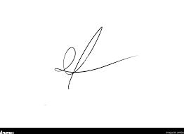

FRCS© NCMP

Clinical Assistant Professor, UBC

Department of Obstetrics and Gynecology SMH